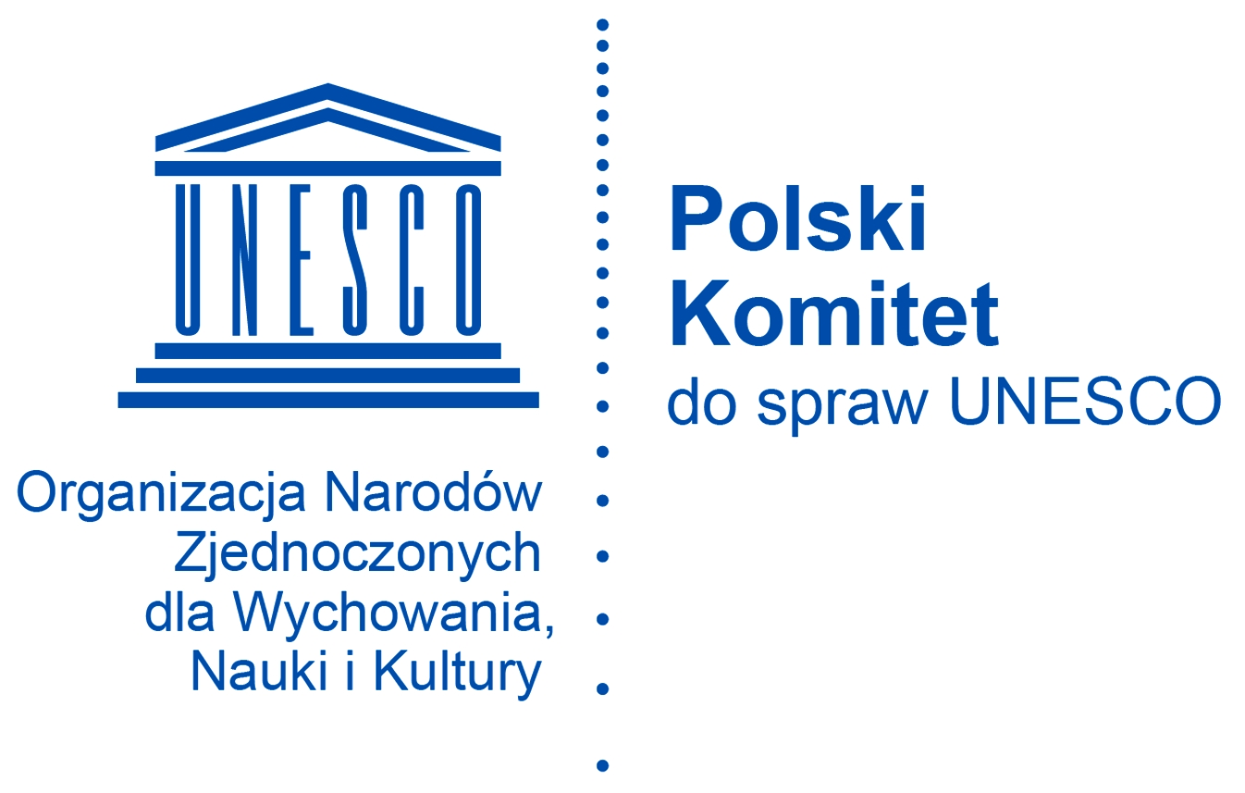

ENTRY FORM

XXXI INTERNATIONAL FESTIVAL OF FINE ARTS COLOR ART

AUTHOR’S FULL NAME

...................................................................................................................................................................................

AGE ........................... GENDER: FEMALE / MALE

NAME AND ADDRESS OR STAMP OF THE SENDING INSTITUTION

.......................................................................................................................................................................

.....................................................................................................................................................................................

PHONE NUMBER ............................................................ E-MAIL ....................................................................................

Full name of the teacher guiding/registering the Entrant

…………………………………………………………………………………………………………………..

No. | TITLE | Category
1. |  | PAINTING AND DRAWING/ GRAPHIC ARTS
2. |  | PAINTING AND DRAWING / GRAPHIC ARTS
3. |  | PAINTING AND DRAWING / GRAPHIC ARTS

I hereby declare that the submitted works have been created solely by the Entrant.

....................................................................................
Date and signature of the parent/legal guardian/teacher
CONSENT to personal data processing in accordance with Article 6 par. (1) point (a) of the Regulation (EU) 2016/679 of the European Parliament and of the Council of 27 April 2016 on the protection of individuals with regard to the processing of personal data and on the free movement of such data and repealing Directive 95/46/EC (General Data Protection Regulation)

I hereby give the Organizer (Goleniowski Dom Kultury – Goleniów Cultural Centre, Słowackiego 1, 72-100 Goleniów, Poland) my permission to process the personal data of the Entrant,
…………..…………..…………..…………..…………..…………..…………….……
(Entrant’s full name)
as well as mine, stated in this entry form for the purposes of carrying out the Art Competition during the International Festival of Fine Arts Color Art taking place in Goleniów, selecting the winners and honorable mention recipients, and distributing information about the competition and the award-winning submissions. I also give my permission to publish the physical likeness of the Entrant and myself, as well as the permission to publish the Entrant’s personal data in connection to promotional and informational activities accompanying the competition.
I also declare that both I and the Entrant have acquainted ourselves with the information on the processing of personal data of the Entrant and their statutory representative provided pursuant to Article 13 of GDPR and that we are aware of all the rights we have according to Articles 15-18 of GDPR.
……………………………………………………………………..
date and legible signature of Entrant’s statutory representative

THE INFORMATION CLAUSE ON PERSONAL DATA PROCESSING
In accordance with Article 13, paragraphs (1) and (2) of the Regulation of the European Parliament and of the Council (EU) 2016/679 of 27 April 2016 on the protection of natural persons with regard to the processing of personal data and on the free movement of such data, and repealing Directive 95/46/EC (General Data Protection Regulation) hereinafter referred to as GDPR, we inform that:
1. The administrator of your personal data is the Director of Goleniów Cultural Centre (GDK) registered under the address: 72-100 Goleniów, ul. Słowackiego 1, Poland (hereinafter referred to as Administrator).
2. In matters concerning your personal data you can also contact our Personal Data Protection Inspector Mr. Bartosz Kaniuk - e-mail: bkaniuk@proinspektor.pl, phone number: 579 979 237.
3. Your personal data will be processed for the purposes of carrying out the Art Competition during the XXIX International Festival of Fine Arts Color Art taking place in Goleniów, selecting the winners and honorable mentions recipients, and distributing information about the Competition and the award-winning submissions. Legal basis for the processing: Article 6, paragraph (1), points (a),(b),(c),(e) of the Regulation of the European Parliament and of the Council (EU) 2016/679 of 27 April 2016 on the protection of natural persons with regard to the processing of personal data and on the free movement of such data, and repealing Directive 95/46/EC (GDPR).
4. The recipients of your personal data will be the authorized persons appointed by the Administrator.
5. Personal data provided by you will be stored for 5 years from the date of conclusion of the festival.
6. You have the right to access your data, the rights to correct, erase and restrict the processing of your personal data, the right to object, and the right to withdraw your consent at any time. The withdrawal of consent shall not affect the lawfulness of processing based on consent before its withdrawal.
7. You have the right to lodge a complaint with a supervisory authority.
8. The provision of your or your child’s personal data by you is voluntary, however, your refusal to do so will be equivalent to refusal to enter the Competition.

PLEASE FILL THIS FORM IN CAPITAL LETTERS ONLY
AND PLACE IT ON THE BACK OF THE ARTWORK

First name | Last name
Age | Gender: FEMALE / MALE
NAME STAMP OF THE SENDING INSTITUTION  Country: | Category: PAINTING AND DRAIWING / GRAPHIC ARTS
TITLE

Full name and telephone number of the person submitting the artwork |  | E-mail address of the person submitting the artwork

